**FUNCTIONAL AND TECHNICAL COMBINED DOCUMENTATION**

**Page (42): Query (Front End Url:** http://localhost:8100/page42/Page42)

**Functional Picture:**

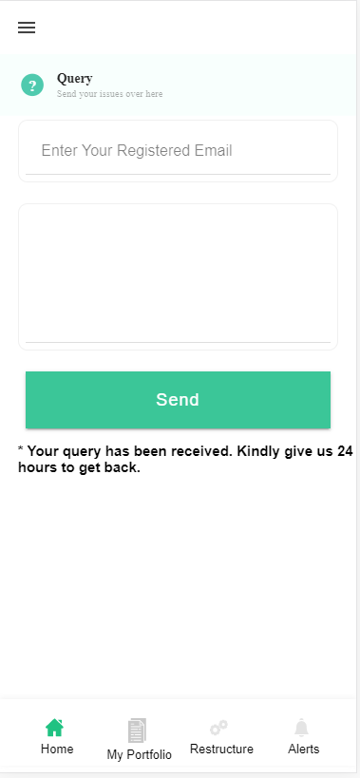

**Technical Explanation (Front End and Back End):**

**In Page42.tsx, we are calling following one method based API:**

1. QueryAPI: see view.py python file from BackEnd

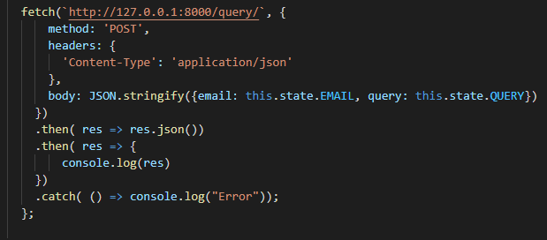

**As you can see above, there is one url:**

* [**http://127.0.0.1:8000/query/**](http://127.0.0.1:8000/query/) **--🡪** QueryAPI

**The Query Data will get saved on database where admin can see the Query in the Admin Page**

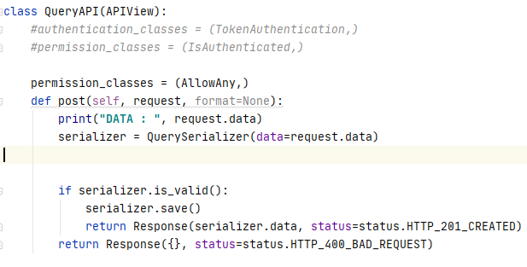

Here we have used **QuerySerializer** for saving the data into the **Query model.**

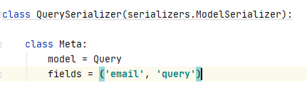

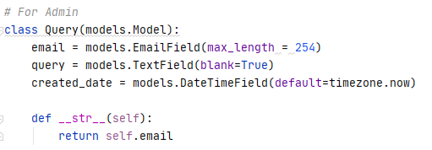

We have made the api route for the same in the urls.py



DONE!!